1.3
a)

>> stem(nx,x)
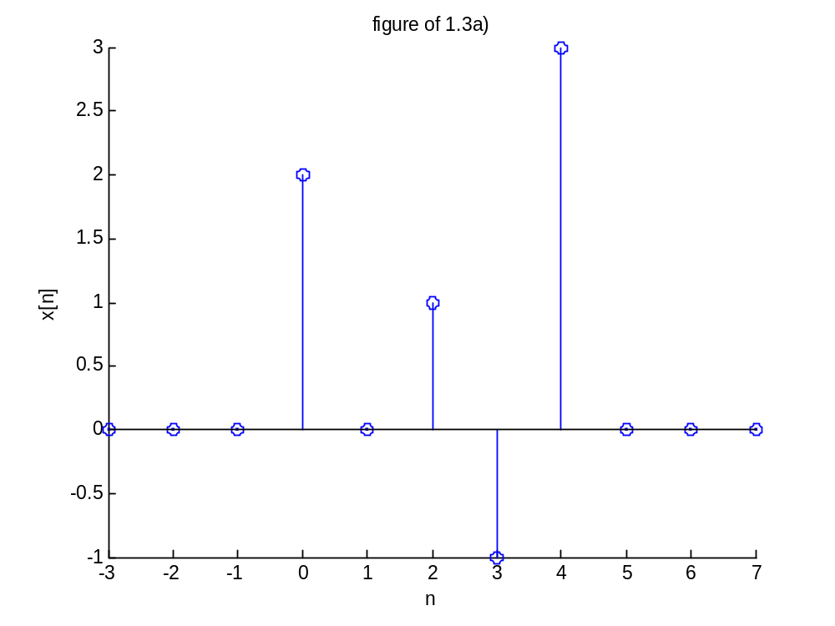
b)
>> ny1=-5:5;
y1=[0 0 0 0 0 2 0 1 -1 3 0];
stem(ny1,y1)

>> ny2=-2:8;
y2=[0 0 2 0 1 -1 3 0 0 0 0];
stem(ny2,y2)

>> ny3=-7:3;
y3=[0 0 0 0 0 0 0 2 0 1 -1];
stem(ny3,y3)

>> ny4=-6:4;
y4=[0 0 0 0 0 0 2 0 1 -1 3];
stem(ny4,y4)

c)
figure1.3c1
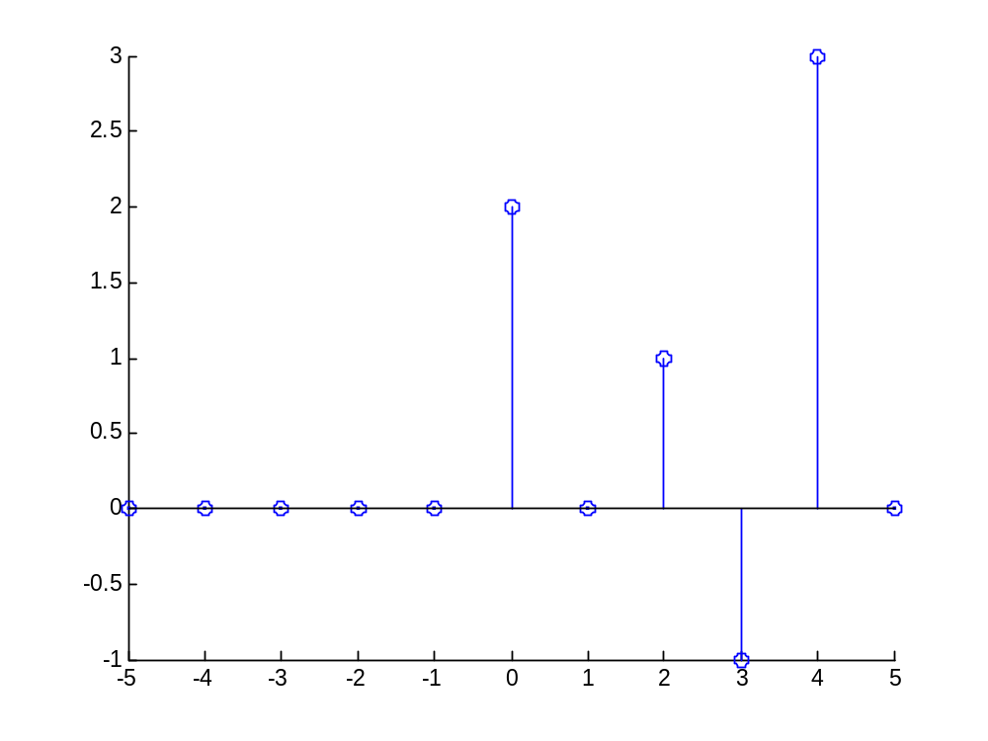

figure1.3c2
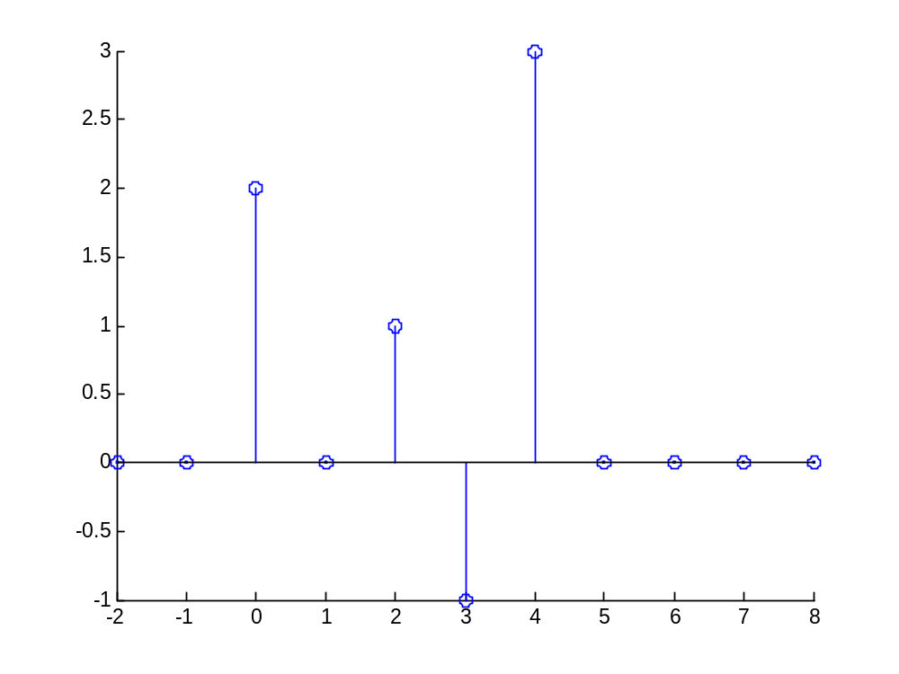

figure1.3c3
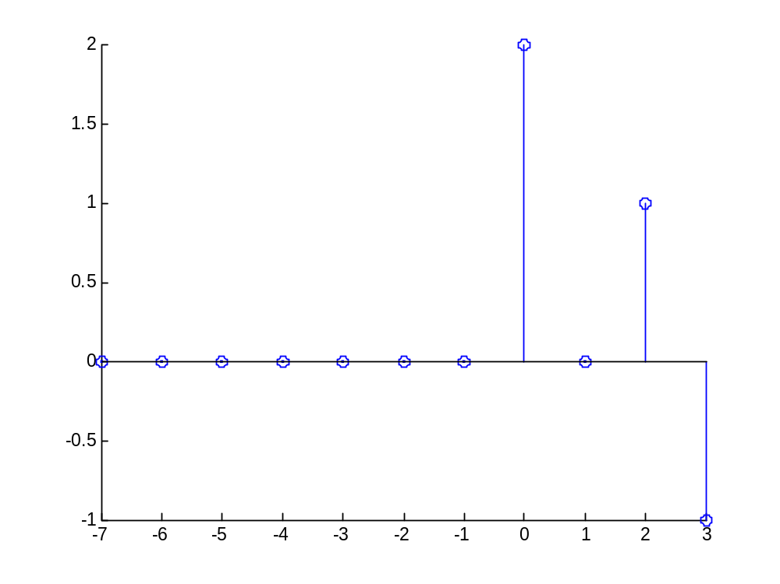

figure1.3c4

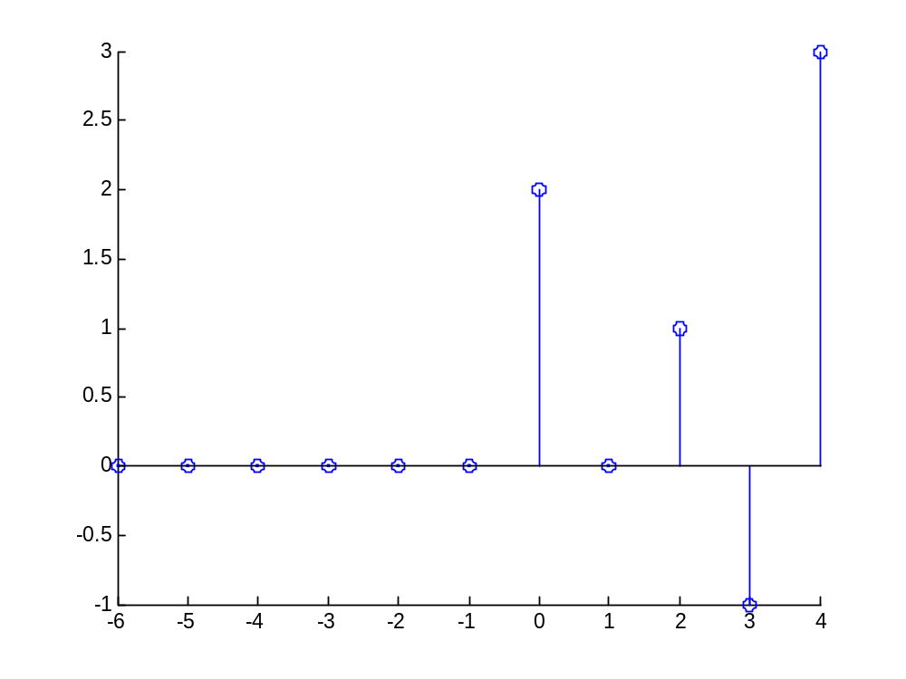

2.1)
b)
>> stem(ny,y) f21b
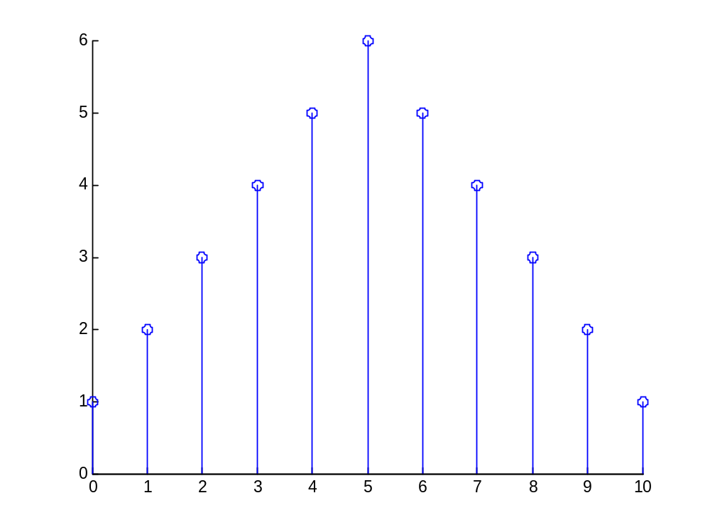
c)
Figure f21c
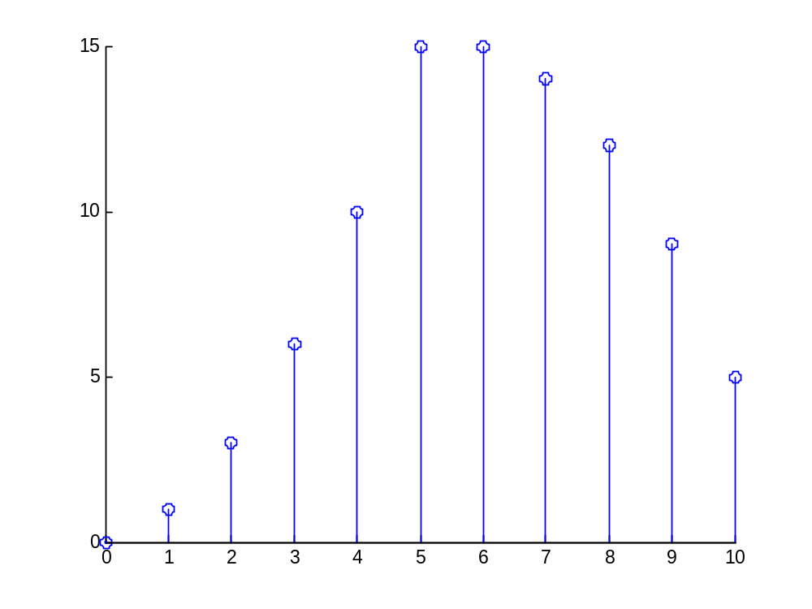
d)
the output values have no difference between each other except is only the time domain. We can see that there is time delay between two outputs.

2.2)

a) >> a1=[1]

a1 =

1

>> b1=[0.5 1 2]

b1 =

0.5000 1.0000 2.0000
b) >> a2=[1 -0.8]

a2 =

1.0000 -0.8000

>> b2=[2]

b2 =

2

c) >> a3=[1 -0.8]

a3 =

1.0000 -0.8000

>> b3=[0 2]

b3 =
0

d)

>> x=[1 2 3 4];
>> a1=[1];
>> b1=[0.5 1 2];
>> y1=filter(b1,a1,x)

y1 =

0.5000 2.0000 5.5000 9.0000
>> x=[1 2 3 4];
>> a2=[1 -0.8];
>> b2=[2];
>> y2=filter(b2,a2,x)

y2 =

2.0000 5.6000 10.4800 16.3840

x=[1 2 3 4];
>> a3=[1 -0.8];
>> b3=[0 2];
>> y2=filter(b3,a3,x)

y2 =

0 2.0000 5.6000 10.4800

2.7)
a)
Figure f27a
